Pour down, you heavens from above
Text: Isaiah 45:8 (refrain); 64:9; 64:6, 43:10-11; 44:22

Refrain:
Pour down you heavens from above and let the skies rain down righteousness

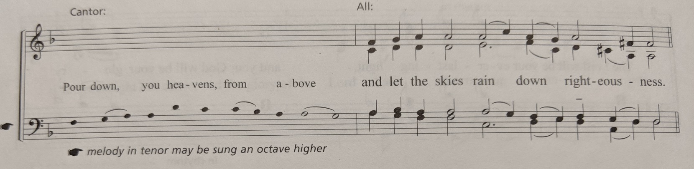

Be not exceeding angry, Lord, do not remember iniquity forever. Your holy cities are a wilderness, Zion is a wilderness, Jerusalem a desolation. Our holy and beautiful house, the temple where our forebears praised you.

REFRAIN

We have all become like unclean things, we all wither like leaves, and our misdeeds carry us off like the wind; for you have hidden your face from us, and left us in the grip of our iniquities.

REFRAIN

You are my witnesses says the Lord, and my servants whom I have chosen that you may know me and believe in me: it is I, I am the Lord, and besides me there is no Savior, there is none who can deliver out of my hand.

REFRAIN

Comfort, O comfort my people, says your God; my salvation will not tarry: I have swept away your transgressions like a cloud: fear not, for I will save you, for I am the Lord your God, the Holy One of Israel, your redeemer.

REFRAIN

